**B.Tech(ECE)-QUANTUM UNIVERSITY-1-Task2-** **Imagine that you are Entrepreneur of a business, you are asked to prepare a design  
Thinking board**

**Design Thinking Board for New Gaming Company**

**1. Product Selection:**

For this scenario, let’s assume that the product is a **"Next-Generation Multiplayer Online Game"**. The game aims to offer an immersive and engaging experience for players, with a strong emphasis on player interaction, community building, and cutting-edge visuals. However, as with most multiplayer online games, the company faces certain challenges that need to be addressed through design thinking.

**Ambiguous Problem:**

The ambiguous problem for this gaming company is **"How can we ensure players have an enjoyable and fair experience while minimizing toxicity and creating a sustainable community?"**

In multiplayer games, player behavior can become a significant problem. Toxic behavior, trolling, and griefing (intentionally annoying or harassing other players) can harm the gaming experience. The challenge is to design solutions that both promote positive behavior and discourage negative actions without feeling overly restrictive or intrusive.

**2. Solution Using Design Thinking**

We can apply the **Design Thinking** process to find creative solutions for this problem. Design Thinking focuses on five main stages: **Empathize**, **Define**, **Ideate**, **Prototype**, and **Test**.

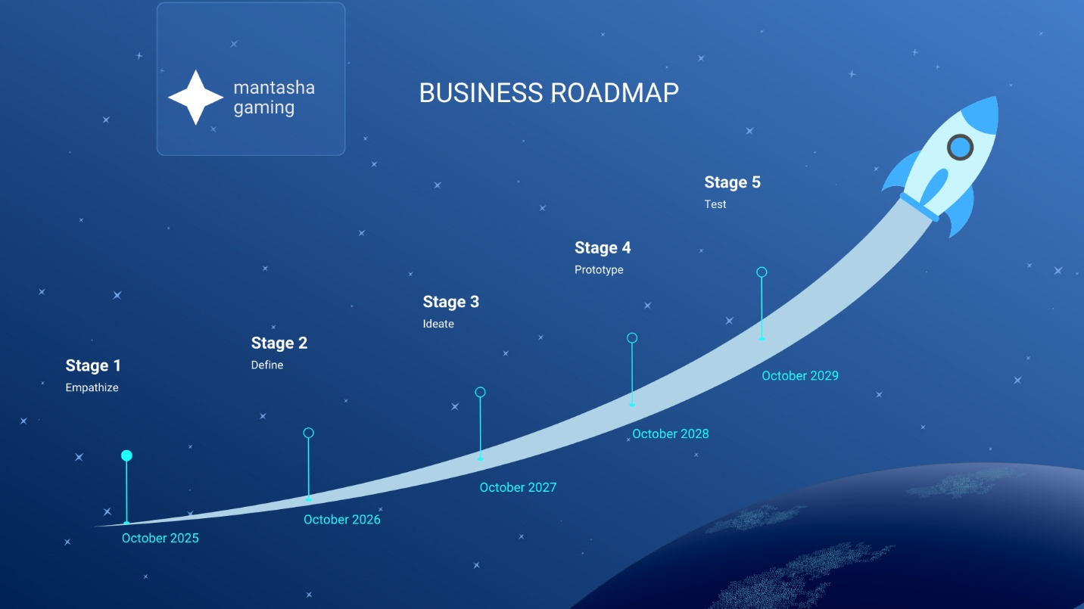

**Design Thinking Process for the Multiplayer Game**

**Stage 1: Empathize**

The goal of this stage is to understand the players’ needs, feelings, and pain points. In this case, we want to understand:

* **Why do players engage in toxic behavior?**
  + Is it frustration from losing matches?
  + Are they upset by the in-game mechanics or balance issues?
  + Are they trying to gain an advantage through harassment or exploiting loopholes?
* **How do players experience the game?**
  + What frustrates players?
  + What features do they enjoy most?
  + What motivates them to stay in a gaming community?

To gather insights, we would:

* **Conduct player interviews and surveys** to understand their gaming experiences, frustrations, and positive interactions.
* **Observe player behavior** in live streams, forums, and gameplay sessions.
* **Analyze in-game data** to identify patterns of toxic behavior and how players interact with one another.

**Stage 2: Define**

In this stage, we synthesize the information gathered during the Empathize phase and clearly define the core problem. The key question to answer here is:

**"How can we create a more positive and fair in-game environment where players can enjoy their experience without being hindered by toxic behavior?"**

From the insights gathered, we may define the following problem statement:

**"Players often engage in toxic behavior because they feel frustrated, unfairly treated, or not properly rewarded for their efforts, which diminishes the enjoyment of the game for everyone. We need to develop strategies and features that promote positive behavior, discourage harassment, and ensure fair play, while not restricting the fun and competitiveness that attracts players."**

**Stage 3: Ideate**

Now that we have a clear understanding of the problem, we need to brainstorm potential solutions. This phase will involve generating a variety of ideas to tackle the problem.

Here are some potential ideas for improving the multiplayer experience and reducing toxicity:

1. **In-Game Reporting System**: Create an intuitive reporting system where players can easily report toxic behavior, abuse, or cheating. However, this system should be designed to avoid false reports or overuse by including automated systems that evaluate reported behavior.
2. **Player Reputation System**: Develop a reputation system where players earn rewards or penalties based on their behavior (positive actions, good sportsmanship, teamwork). For example, players who frequently communicate constructively and cooperate in teams would receive a higher reputation score, while toxic players would face consequences like temporary bans or penalties.
3. **Matchmaking Based on Behavior**: Implement a matchmaking system that pairs players based on their behavior scores. Players with good reputations could be matched with others who exhibit positive behavior, while those with toxic reputations would be matched with similar players.
4. **Community Moderation Tools**: Allow players to vote or moderate in-game events (such as chat or forums). Players can moderate the chat by flagging inappropriate content or even voting to mute toxic players in their current session.
5. **Dynamic Content and Rewarding Positive Behavior**: Include in-game rewards for players who are cooperative, friendly, and demonstrate good sportsmanship. Positive reinforcement can help change the behavior of the community over time.

**Stage 4: Prototype**

Once we have a few ideas, we’ll move to the prototyping phase, where we start developing and testing small versions of these solutions.

1. **Prototype 1: In-Game Reporting System**
   * **Features**: Easy-to-use interface for reporting toxic behavior, harassment, and rule-breaking. It includes both automated AI-based evaluation of behavior and manual player reports.
   * **Testing**: Roll out the reporting system to a select group of players to gather feedback on usability and effectiveness.
2. **Prototype 2: Player Reputation System**
   * **Features**: Create a system where players have a reputation score based on their in-game behavior. Positive behaviors (like teamwork and helping others) increase the score, while negative behaviors (like griefing) decrease it.
   * **Testing**: Introduce the reputation system for a limited group of players, testing how it impacts the overall player experience.
3. **Prototype 3: Matchmaking Based on Behavior**
   * **Features**: Design a matchmaking system that incorporates player behavior ratings into the criteria for match pairing.
   * **Testing**: Test the matchmaking system and evaluate whether players with good behavior are enjoying a better experience and whether toxic players are being paired more appropriately.

**Stage 5: Test**

After prototyping, we need to test the solutions with real users. Testing should be conducted on a small scale initially, with iterative improvements based on feedback.

* **User Testing of Prototypes**: Have a group of players engage with the new features (reporting system, reputation system, behavior-based matchmaking) and gather feedback on:
  + Usability: Is the feature easy to use and understand?
  + Effectiveness: Does it reduce toxic behavior? Does it increase positive interaction?
  + Player Satisfaction: Are players more satisfied with their experience after using these features?
* **A/B Testing**: Use A/B testing to compare the effectiveness of different strategies. For instance, compare the experience of players who have access to the reputation system versus those who don’t.
* **Iterate Based on Feedback**: Use feedback to continuously improve the systems, addressing any issues, bugs, or loopholes.